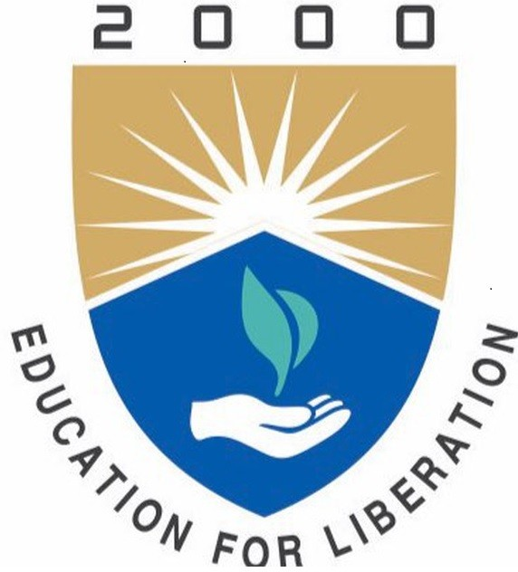
INSTITUTE OF AERONAUTICAL ENGINEERING
(Autonomous)
Dundigal, Hyderabad - 500 043
COMPUTER SCIENCE AND ENGINEERING
TECH TALK TOPICS

Course Title
Course Code
Program
Semester
Course Type
Regulation
Course Structure | Theory |  |  | Practical
 | Lecture | Tutorials | Credits | Laboratory | Credits
Course Coordinator

COURSE OBJECTIVES:
The students will try to learn:

COURSE OUTCOMES:
After successful completion of the course, students should be able to:

TECH TALK TOPICS:

S.No | Title of the Topic | Source | Pub lisher | CO’s
1
2
3
4
5
6
7
8
9
10

Course Coordinator: HOD CSE

